Chapter 4

**RESULTS AND DISCUSSION**

This chapter summarizes the study's findings and conclusions to the problems concerned with the development of the proposed Monitoring System for the municipality of Bolinao and provides recommendations on its proper implementation and further developments.

**Current Process in Tourism Office System**

The proponents conducted an interview with the Municipal Tourism Officer of Bolinao, Ms. Mary C. De Guzman and Mr. Darwin Borines. The proponents were able to determine that the Tourism Office is using manual processes and Google Forms in recording tourism activities.

Registration of Tourists’ Data. Registration form is being distributed to a list of tourist sites and registered establishments by the Bolinao Tourism Office.

Tourist’s data is being collected by the Bolinao Tourism Office by requesting newly arrived guests to fill-up a registration form on designated tourist sites and establishments. The guest will need to write down their information such as: name, nationality, age, date of birth, gender, address, contact information, date of arrival, and travel history. This process is required for every tourist site and establishment being visited by the guests.

Figure 8:

Registration of Tourists’ Data.

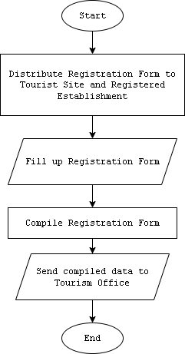

Collecting tourist data manually. Manual data collection of registration forms is being done by the tourism office to tourist sites and establishments that has cases of poor network signals. Schedules of collecting the registration forms may vary from location to location, though it is required to collect these reports in a monthly basis.

The collected data will then be compiled in the tourism office for encoding.

Figure 9:

Collecting Tourist Data Manually.

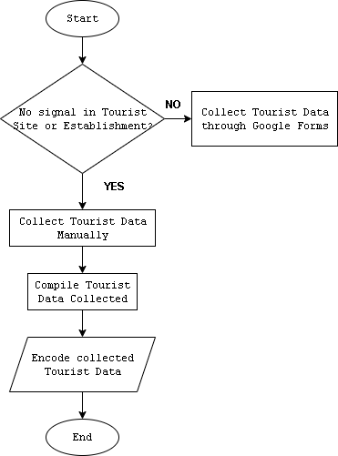

Tourist Data Collection through Google Forms. Tourist data collection through Google Forms is being made when the tourist site and establishment has access to the Internet.

The Google forms are made by the IT Staff of the tourism office. Links will be distributed to the tourist sites and establishments that have access to the Internet. After accepting responses, all the data collected will be encoded by the tourism office for compilation.

Figure 10:

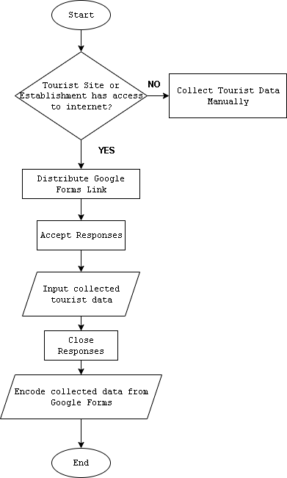Tourist Data Collection through Google Forms.

Encoding of data in Excel. Encoding is being done by the tourism office manually through constant online work in the office. All data collected manually and through Google forms are then being compiled in a monthly basis. The compiled data will then be encoded by the statistician of the tourism office through an Excel format provided by the Department of Tourism.

The encoded data by the statistician will then be sent to the Department of Tourism. These datas will also be used by the Tourism Office to analyze tourism activities.

Figure 11:

Encoding of Data in Excel.

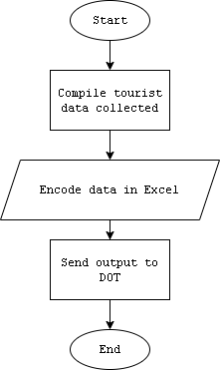

**Difficulties encountered in the current system of Tourism Office**

Based on the data gathered from the interview conducted with Ms. Mary C. De Guzman, the following are the difficulties encountered by the Tourism Office:

Limited network signals in other sites and establishments. Limited network signals to certain tourist sites and establishments results in manual collection of registration forms and manual generation of reports. This difficulty makes it hard for the tourism office to collect tourist data in a timely manner.

Time-consuming collection of data. The tourism office will need to go to the tourist sites and establishments that have problem with network signals to collect tourist data. Certain areas take time to reach because there are some tourist sites and registered establishments that are in areas that require sailing such as the tourist site in Santiago Island. Majority of tourist sites and registered establishments are also located in remote areas of Bolinao.

Inconvenience to guests. Peak seasons and holiday causes inconvenience to the guests specially to famous tourist sites or establishments where heavy trafficks may occur and results for guests to find other site or establishment for accomodation. The lack of information in status of this destinations results to inconvenience to guests.

**Features of the Proposed Tourism Monitoring System**

The development of Tourism Monitoring System for Bolinao is designed to provide the following features:

Register Account. The system feature can only be accessed by making the user register an account. OTP (One-time Password) will be required to successfully register.

By making the user register, they will be able to access the basic core features of the system.

Figure 12:

Register Account.

User Profile Setting. This feature allows the user to see their Profile. This can be accessed upon successful login of the user and by navigating to the right part of the header.

Users will be able to edit their Profile Information and they are required to also add their gender and address to be able to request for booking.

The profile information by the user will serve as the basis in booking entry in destinations registered in the system.

Figure 13:

User Profile Setting.

Dashboard. This feature allows the user to see the current numbers of visits of a tourist site or establishments. The number of visits in the establishment will update in real-time whenever there is a new booking accepted by the staff accounts.

Figure 14:

Dashboard.

Live Map Counter. This feature allows users to see the map of Bolinao via map pins of the tourist sites and establishments. The counter will also update in real-time whenever a booking entry is approved.

As for privacy concerns, the live map counter in the homepage will only show the pins of every tourist site and establishments. To see the live number of total visits in the map, the user needs to login or register an account.

Figure 15:

Live Map Counter.

Booking. This feature allows the user to be able to book in their chosen tourist site or establishment. This is a two-step process, where the first process will be the user info, this is to make sure that all information is correct before proceeding with the next page. User information can be modified by navigating to the Profile Setting page.

The second step will proceed by asking for additional information for the user. Users will be able to choose in a drop box the list of registered tourist sites or establishments in the system. Upon choosing the location, the user will be given a ticket code that will be to the staff assigned to that tourist site or establishment. The staff will need to approve the request upon confirming the ticket code of the user. The following figure shows the steps in booking:

Figure 16:

Booking – User Info.

Figure 17:

Booking – Additional Information.

Figure 18:

Booking – Generate Ticket Number.

Manage Request. This feature allows the user to see the list of active booking requested. Users can also cancel the booking request.

Figure 19:

Request Logs.

Add Site Location. This will allow the tourism office to add specific locations of tourist sites and registered establishments according to its name, latitude, and longitude.

Figure 20:

Adding Site Location in Live Map.

Staff Account Creation. This feature allows the tourism office to create designated staff accounts for specific tourist sites and registered establishments.

Staff accounts have different functionalities that will help in managing and monitoring the designated site or establishment of that account. Staff accounts can only be created if the designated site or establishment has no existing staff account.

Figure 21:

Staff Account Creation.

Notification. Staff accounts will be able to create notifications for users to see updates related to the site or establishments. The notifications can be seen by the users when created including which staff account created the notification. The figures below show the following functionalities of the feature:

Figure 22:

Create Notification.

Figure 23:

Create Notification Modal.

Figure 24:

Notification Page – User.

**Acceptability test of Tourism Monitoring System**

In the completion of the proposed Tourism Monitoring System for Bolinao, the system will be assessed by the Tourism Office and the IT faculty of PSU – ACC.

Functionality. Table 5 summarizes evaluators' perspectives on the system's functionality. The system's functionality is rated by respondents with an overall mean of 3.8, which translates as Acceptable. In terms of suitability, the functions of the system are appropriate, with a total average weighted mean of 3.9, which translates to Acceptable. The measured data can be used by the tourism office for data appropriateness. In terms of accuracy, Tourism Monitoring System has a total average weighted mean of 3.78, which translates to Acceptable. The Tourism Monitoring System adheres to existing standards and policies with total average weighted mean of 3.74, which translates as Acceptable. For security, the system prevents unauthorized access with an average weighted mean of 3.76, which is considered Acceptable. The developed system can provide security to the users of the system, this is also the same with how the routes can be accessed.

Table 5:

System Evaluation According to Functionality.

|  |  |  |
| --- | --- | --- |
| **FUNCTIONALITY** | **Mean** | **Description** |
| 1. Suitability – The functions of the system are appropriate. | 3.9 | Acceptable |
| 2. Accuracy – The system’s results are accurate. | 3.78 | Acceptable |
| 3. Compliance – It adheres to existing standards and policies. | 3.74 | Acceptable |
| 4. Security – It prevents unauthorized access. | 3.76 | Acceptable |
| **Weighted Mean** | 3.8 | Acceptable |

Reliability. Table 6 depicts users' perceptions of the web-application's dependability as evaluators. The web-application received a 3.56 mean, which translates to Acceptable, in terms of maturity, which states the minimal frequency of software faults and failures. This means that application errors are less likely to occur. In terms of fault tolerance, the web application received a mean of 3.72. This indicates that the application can handle system errors. The application received a mean of 3.76 for recoverability, indicating that it can easily recover its performance in the event of an error. The Tourism Monitoring System's overall weighted mean is 3.68, which is marked as Acceptable.

Table 6:

System Evaluation According to Reliability.

|  |  |  |
| --- | --- | --- |
| **RELIABILITY** | **Mean** | **Description** |
| 1. Maturity – There is a minimum frequency of software faults/failures. | 3.56 | Acceptable |
| 2. Fault Tolerance – The system can handle system errors. | 3.72 | Acceptable |
| 3. Recoverability – System’s performance is re-establishing from failure. | 3.76 | Acceptable |
| **Weighted Mean** | 3.68 | Acceptable |

Usability. Table 7 shows users’ perceptions as evaluators of the application's usability. According to understandability, which states that the concepts incorporated in the application are easy to recognize, the application garnered a mean of 3.87. This shows that the words, icons, and buttons added to the web-application are easy to understand. In terms of learnability, the application garnered a mean of 3.72. This states that the processes occurring in the application are easy to understand. For operability, the application garnered a mean of 3.83 which states that the controls and different interfaces are easy to navigate. The overall weighted mean of the application is 3.82, marked as Acceptable.

Table 7:

System Evaluation According to Usability.

|  |  |  |
| --- | --- | --- |
| **USABILITY** | **Mean** | **Description** |
| 1.Understandability – Concepts are easily recognized. | 3.87 | Acceptable |
| 2. Learnability – The system’s functions are easy to learn | 3.76 | Acceptable |
| 3. Operability – The system is easy to use or operate. | 3.83 | Acceptable |
| **Weighted Mean** | 3.82 | Acceptable |

Efficiency. Table 8 depicts users’ perceptions as evaluators of the web-application's efficiency. According to its time behavior, which states a fast response time from server to end-user, the application garnered a mean of 3.85. This means that the response time in sending and receiving data from server to end-users of the web-application is Acceptable. The application garnered a mean of 3.81 in terms of resource behavior. This states that the data inputs for the web-application are easy to provide. The overall weighted mean of the application is 3.83, marked as Acceptable.

Table 8:

System Evaluation According to Efficiency.

|  |  |  |
| --- | --- | --- |
| **EFFICIENCY** | **Mean** | **Description** |
| 1. Time Behavior – There is a fast response time in the system. | 3.85 | Acceptable |
| 2. Resource Behavior – Resources used for system performance are accessible. | 3.81 | Acceptable |
| **Weighted Mean** | 3.83 | Acceptable |

Maintainability. Table 9 depicts users' perceptions of the web application's maintainability as evaluators. The application garnered a mean of 3.78 for its analyzability, which states that failures are easily identified. This means that the application does its job of informing the user about errors in the application's processes. The web-application’s changeability, which states as, effort in modifying the system garnered a mean of 3.74. It demonstrates that modifying the web-applications requires less effort. The application received a mean of 3.67 for stability. This indicates that the web-application's resources are simple to modify. The application's overall weighted mean is 3.73, which is marked as Acceptable.

Table 9:

System Evaluation According to Maintainability.

|  |  |  |
| --- | --- | --- |
| **MAINTANABILITY** | **Mean** | **Description** |
| 1. Analyzability – There is less effort in identifying system failure causes. | 3.78 | Acceptable |
| 1. Changeability – Effort in modifying the system | 3.74 | Acceptable |
| 1. Stability – Sensitivity to modification | 3.67 | Acceptable |
| **Weighted Mean** | 3.73 | Acceptable |

Portability. Table 10 depicts users' perceptions of the web application's portability. The respondents rate the system's portability as Acceptable, as evidenced by an overall mean of 3.82. With an average weighted mean of 3.74, which translates as Acceptable, specification changes in the system are simple. In terms of Installability, there is an easy process deploying the web-application, with an average weighted mean of 3.87, which translates as Acceptable. The web-application conforms to portability standards with an average weighted mean of 3.85, which translates as Acceptable.

Table 10:

System Evaluation According to Portability.

|  |  |  |
| --- | --- | --- |
| **PORTABILITY** | **Mean** | **Description** |
| 1. Adaptability – Specification changes are done easily. | 3.74 | Acceptable |
| 1. Installability – There is effortless process of installing the system. | 3.87 | Acceptable |
| 1. Conformance – System is compliant to portability standards. | 3.85 | Acceptable |
| **Weighted Mean** | 3.82 | Acceptable |

Table 11 and Table 12 shows the overall weighted mean of the acceptability test of the Tourism Monitoring System from the data garnered from the locale respondents and end-users.

Table 11:

Overall Weighted Mean for Locale Respondents.

|  |  |  |
| --- | --- | --- |
| **AREA** | **Average Weighted Mean** | **Description** |
| 1. Functionality | 3.9 | Acceptable |
| 1. Reliability | 3.73 | Acceptable |
| 1. Usability | 3.82 | Acceptable |
| 1. Efficiency | 3.9 | Acceptable |
| 1. Maintainability | 3.81 | Acceptable |
| 1. Portability | 3.84 | Acceptable |
| **Overall Weighted Mean** | 3.83 | Acceptable |

Table 12:

Overall Weighted Mean for End-Users.

|  |  |  |
| --- | --- | --- |
| **AREA** | **Average Weighted Mean** | **Description** |
| 1. Functionality | 3.74 | Acceptable |
| 1. Reliability | 3.69 | Acceptable |
| 1. Usability | 3.86 | Acceptable |
| 1. Efficiency | 3.84 | Acceptable |
| 1. Maintainability | 3.70 | Acceptable |
| 1. Portability | 3.84 | Acceptable |
| **Overall Weighted Mean** | 3.78 | Acceptable |

With a computed overall weighted mean for locale respondents' acceptability test of 3.83 and end-users' acceptability test of 3.78, both interpreted as Acceptable, the web application is ready for deployment.

Table 13 and Table 14 shows the overall weighted mean of the acceptability test of the Tourism Monitoring System.

Table 13:

Overall Weighted Mean for Tourism Officers.

|  |  |  |
| --- | --- | --- |
| **AREA** | **Average Weighted Mean** | **Description** |
| 1. Functionality | 3.75 | Acceptable |
| 1. Reliability | 3.50 | Acceptable |
| 1. Usability | 3.66 | Acceptable |
| 1. Efficiency | 3.50 | Acceptable |
| 1. Maintainability | 3.33 | Acceptable |
| 1. Portability | 3.83 | Acceptable |
| **Overall Weighted Mean** | 3.59 | Acceptable |

Table 14:

Overall Weighted Mean for PSU – ACC IT Staff.

|  |  |  |
| --- | --- | --- |
| **AREA** | **Average Weighted Mean** | **Description** |
| 1. Functionality | 3.50 | Acceptable |
| 1. Reliability | 3.33 | Acceptable |
| 1. Usability | 3.55 | Acceptable |
| 1. Efficiency | 3.50 | Acceptable |
| 1. Maintainability | 3.55 | Acceptable |
| 1. Portability | 3.55 | Acceptable |
| **Overall Weighted Mean** | 3.50 | Acceptable |

The web-application is ready for deployment with a computed overall weighted mean for Bolinao tourism officers’ acceptability test of 3.59 and PSU - IT staff acceptability test of 3.50, both interpreted as Acceptable.